SMuRP

User Manual

Brendan Armstrong, Brooke Brown,

Alyssa Kutney, Caitlin McElwee,

Caroline Grala, Kristelle Lucero

**TABLE OF CONTENTS**

***1.0 GENERAL INFORMATION…………………………………………………*3**

**1.1 Application Overview……………………………………………………………..4**

**1.2 Organization of the Manual……………………………………………………...4**

***2.0 SYSTEM SUMMARY………………………………………………………..*5**

**2.1 System Configuration………………………………………………………..…..6**

**2.2 User Access Levels……………………………………………………………….6**

***3.0 GETTING STARTED………………………………………………………...*7**

**3.1 Installing and Logging In………………………………………………………...8**

**3.2 System Menu……………………………………………………………………….9**

***4.0 USING SMURP……………………………………………………………..*10**

**4.1 Login……………………………………………………………………………….11**

**4.2 Feed………………………………………………………………………………...12**

**4.3 Profile……………………………………………………………………….……..13**

**4.4 Recommended Music……………………………………………………..…….14**

**4.5 Recommended Friends…………………………………………………………15**

**4.6 Rated Songs……………………………………………………………………...16**

4.6.1 Likes…………………………………………………………………………………………..

4.6.2 Dislikes………………………………………………………………………………………..

**4.7 History……………………………………………………………………………..19**

**4.8 Friends……………………………………………………………………………..20**

4.8.1 Users You Follow…………………………………………………………………………….

4.8.2 Users Who Follow You……………………………………………………………………...

***5.0 REPORTING ISSUES……………………………………………………..*22**

**1.0 GENERAL INFORMATION**

**1.0 GENERAL INFORMATION**

General Information section explains in general terms the system and the purpose for which it is intended.

**1.1 Application Overview**

SMuRP is an app that allows users to discover new music and make friends based on their musical tastes. Users record the music that they listen to (marking their likes and dislikes), and a machine learning algorithm matches them to music they are likely to enjoy based on their musical preferences. In addition, the service also suggests other users to follow with similar musical tastes. Users can then view what music the people they follow are listening to.

**1.2 Organization of the Manual**

The user’s manual consists of five sections: General Information, System Summary, Getting Started, Using SMuRP, and Reporting Issues.

The General Information section contains the application overview and the general outline for the user manual.

The System Summary section provides both the hardware and software requirements for the application, along with the user access levels.

The Getting Started section provides information about how to install the app and login.

The Using SMuRP section provides a short walkthrough of the system functions and includes diagrams of each screen.

The Reporting Issues section provides the contact information for app support.

**2.0 SYSTEM SUMMARY**

**2.0 SYSTEM SUMMARY**

The System Summary provides an overview of the system, outlining the system’s hardware and software requirements and user access levels.

**2.1 System Configuration**

SMuRP operates on mobiles devices that have an Android or iOS operating system. To use the application a connection to the Internet is required. Accessing data from the database and saving data to the database requires Internet connection. After installing the application to the mobile device and connecting to Internet, SMuRP is ready to be used.

**2.2 User Access Levels**

SMuRP is available for download and use by any user. However, only the developers have access to the database and server code.

**3.0 GETTING STARTED**

**3.0 GETTING STARTED**

This section explains how to download SMuRP and install it onto your device. In addition, this section presents images of the system menu.

**3.1 Installing and Logging In**

In order to download SMuRP to your mobile device, you can visit our GitHub page: <https://github.com/LuckyOwl13/SMuRP>

In addition, you will need to have an existing *Last.fm* account. If you do not have a *Last.fm* account, you will not be able to utilize our app.

You can create a *Last.fm* account at: <https://www.last.fm/join>

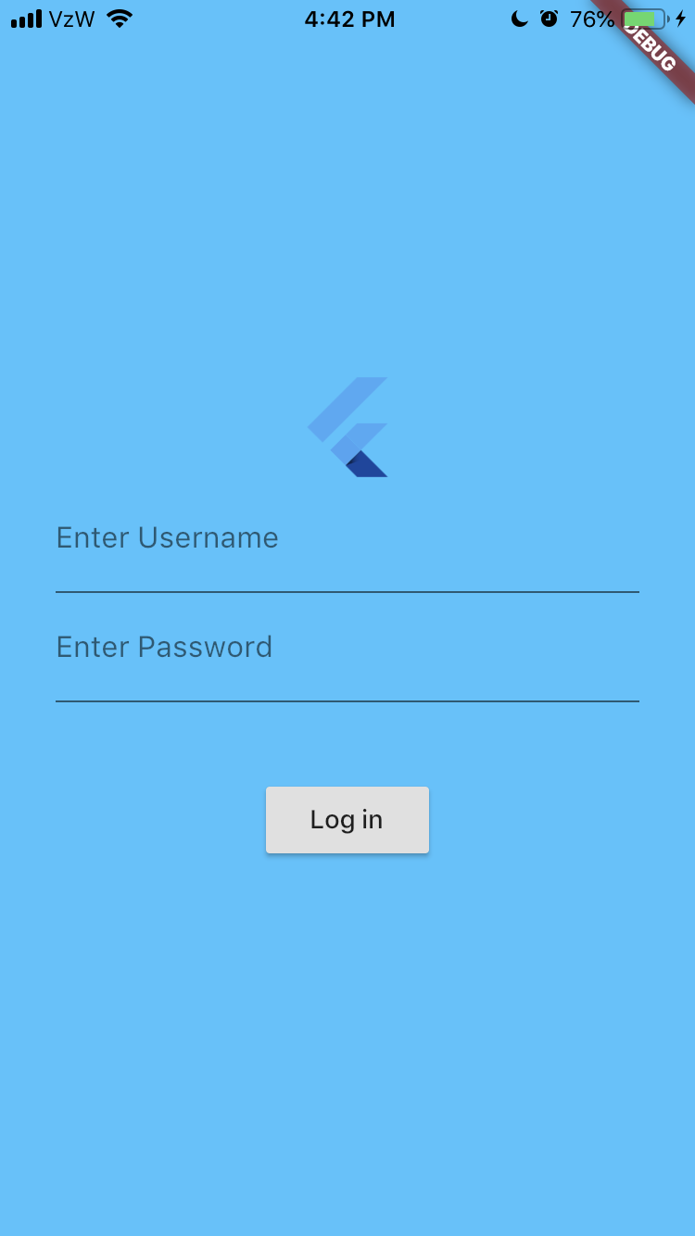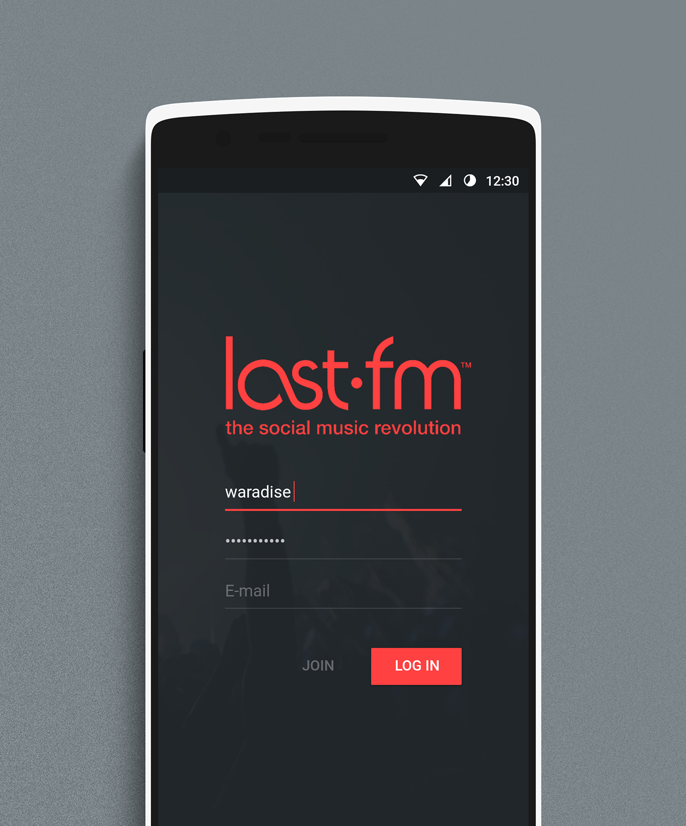

Figure 1. User Login for SMuRP (left) and Last.fm (right)

**3.2 System Menu**

The SMuRP system menu provides navigation to different screens. The navigation menu is housed on the feed page. It is accessible by swiping left on the feed or by tapping on the menu button (three horizontal lines at upper right corner of screen). The navigation menu is also where the user must go in order to logout of the app.

Pages linked to the navigation menu include the user’s *Profile Page*, *Recommended Music*, *Recommended Friends*, *Rated Songs*, *History*, and *Friends Page*.

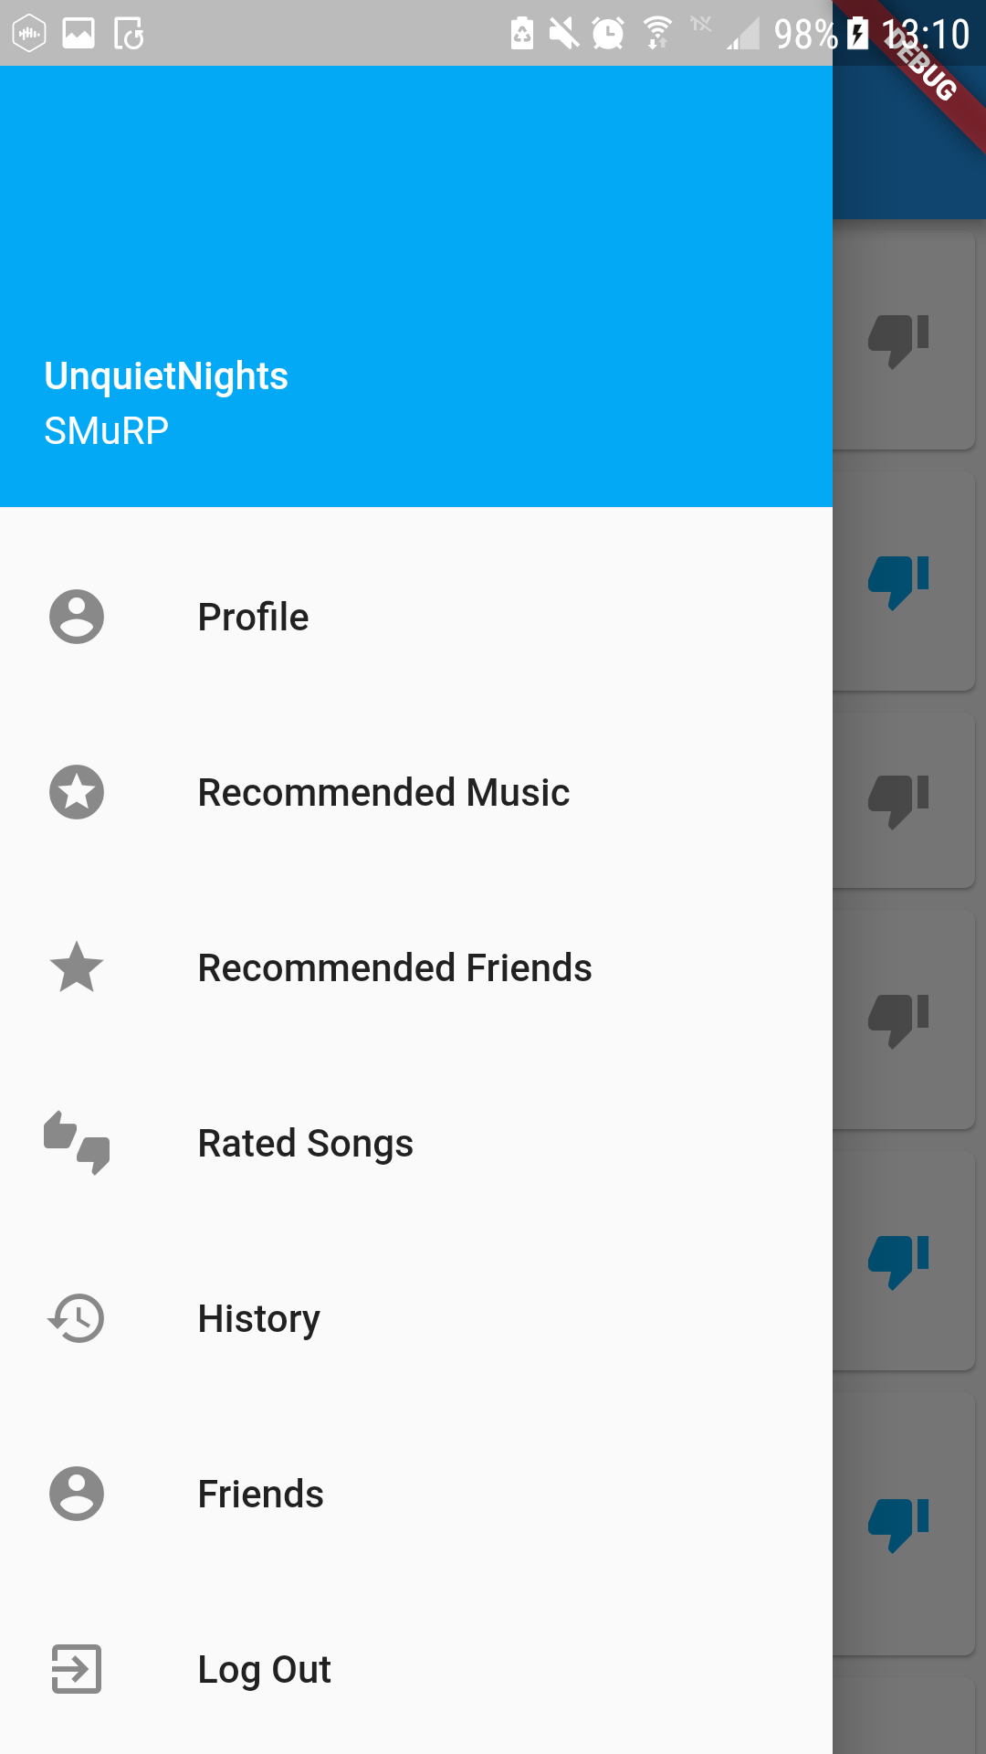

Figure 2. System Menu

**4.0 USING SMURP**

**4.0 USING SMURP**

This section walks the user through each screen and its functionality.

**4.1 Login**

This screen is where you will enter your username and password. If you enter an incorrect username or incorrect password, an error message will pop up and will not let you pass the login screen until a correct username and password is inputted. After successfully logging into their account, the user will then proceed onto the next screen. Everytime you login, your listened songs are updated to include what you have listened to on Last.fm.

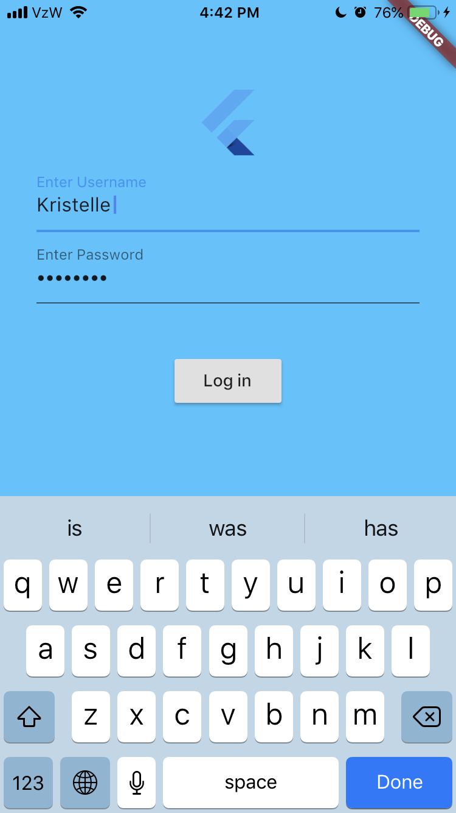

Figure 3. User Login

**4.2 Feed**

The *Home Feed* is the next screen to appear after logging in. This screen displays the songs that have been recently liked or listened to by you and any users you follow. From this screen you have the ability to like or dislike any songs you see on your feed.

Another important thing to note is the navigation menu button in the top left-hand corner of the screen. The navigation menu will bring you to a different page, as mentioned in section 3.2 Figure 2.

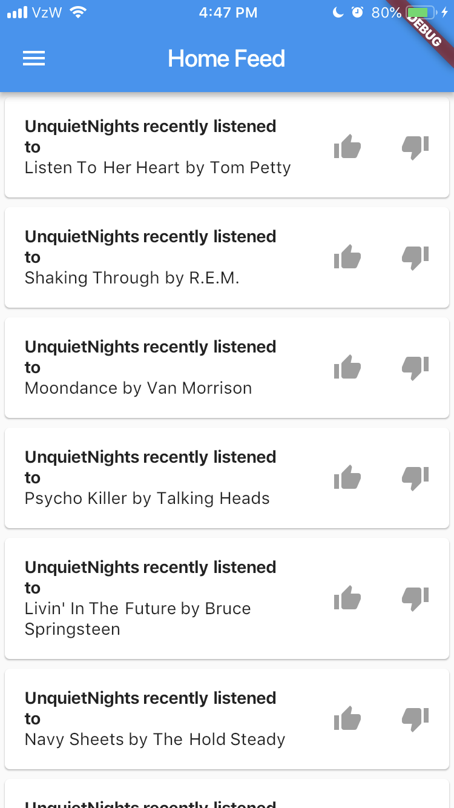

Figure 4. Feed

**4.3 Profile**

The *Profile* *Page* displays information about a user. This information includes the username, email, and join date. In addition, this page also displays a list of the user’s most recent likes and listens.

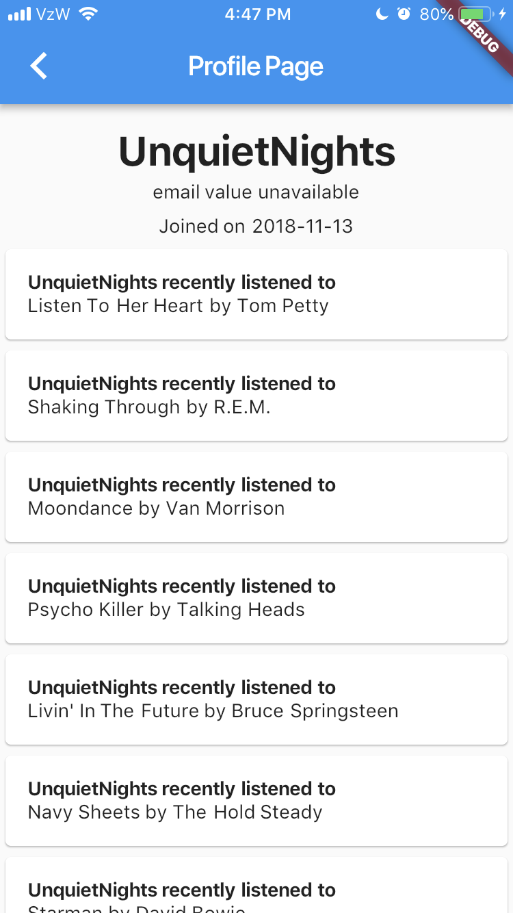

Figure 5. Profile Page

**4.4 Recommended Music**

The *Song Recommendations* page lists several songs that a user has not listened to and not liked yet. These recommendations are based around what songs a user has already liked. A user then has the option to like or dislike the outputted songs. When the user refreshes this page, the songs that were liked or disliked will be replaced with new recommended songs. The songs that were not liked or disliked will remain until interacted with.

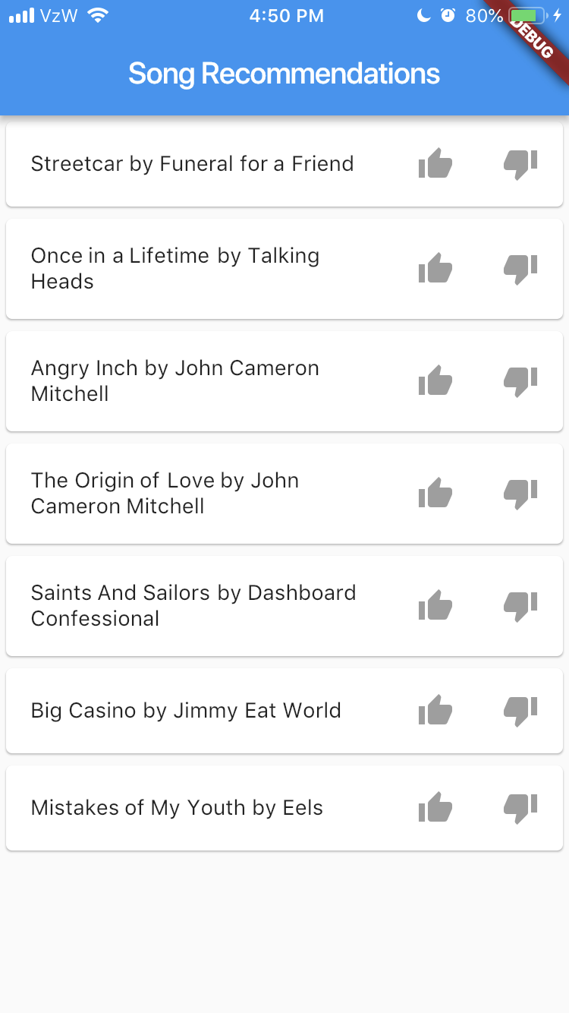

Figure 6. Recommended Music

**4.5 Recommended Friends**

The *Recommended Friends* page lists several new users that the user logged in does not follow. The user has the option to then follow the user. You can click on the individual usernames listed to see that specific users recently liked/listened to songs. The users outputted have a similar listening history to the user logged in.

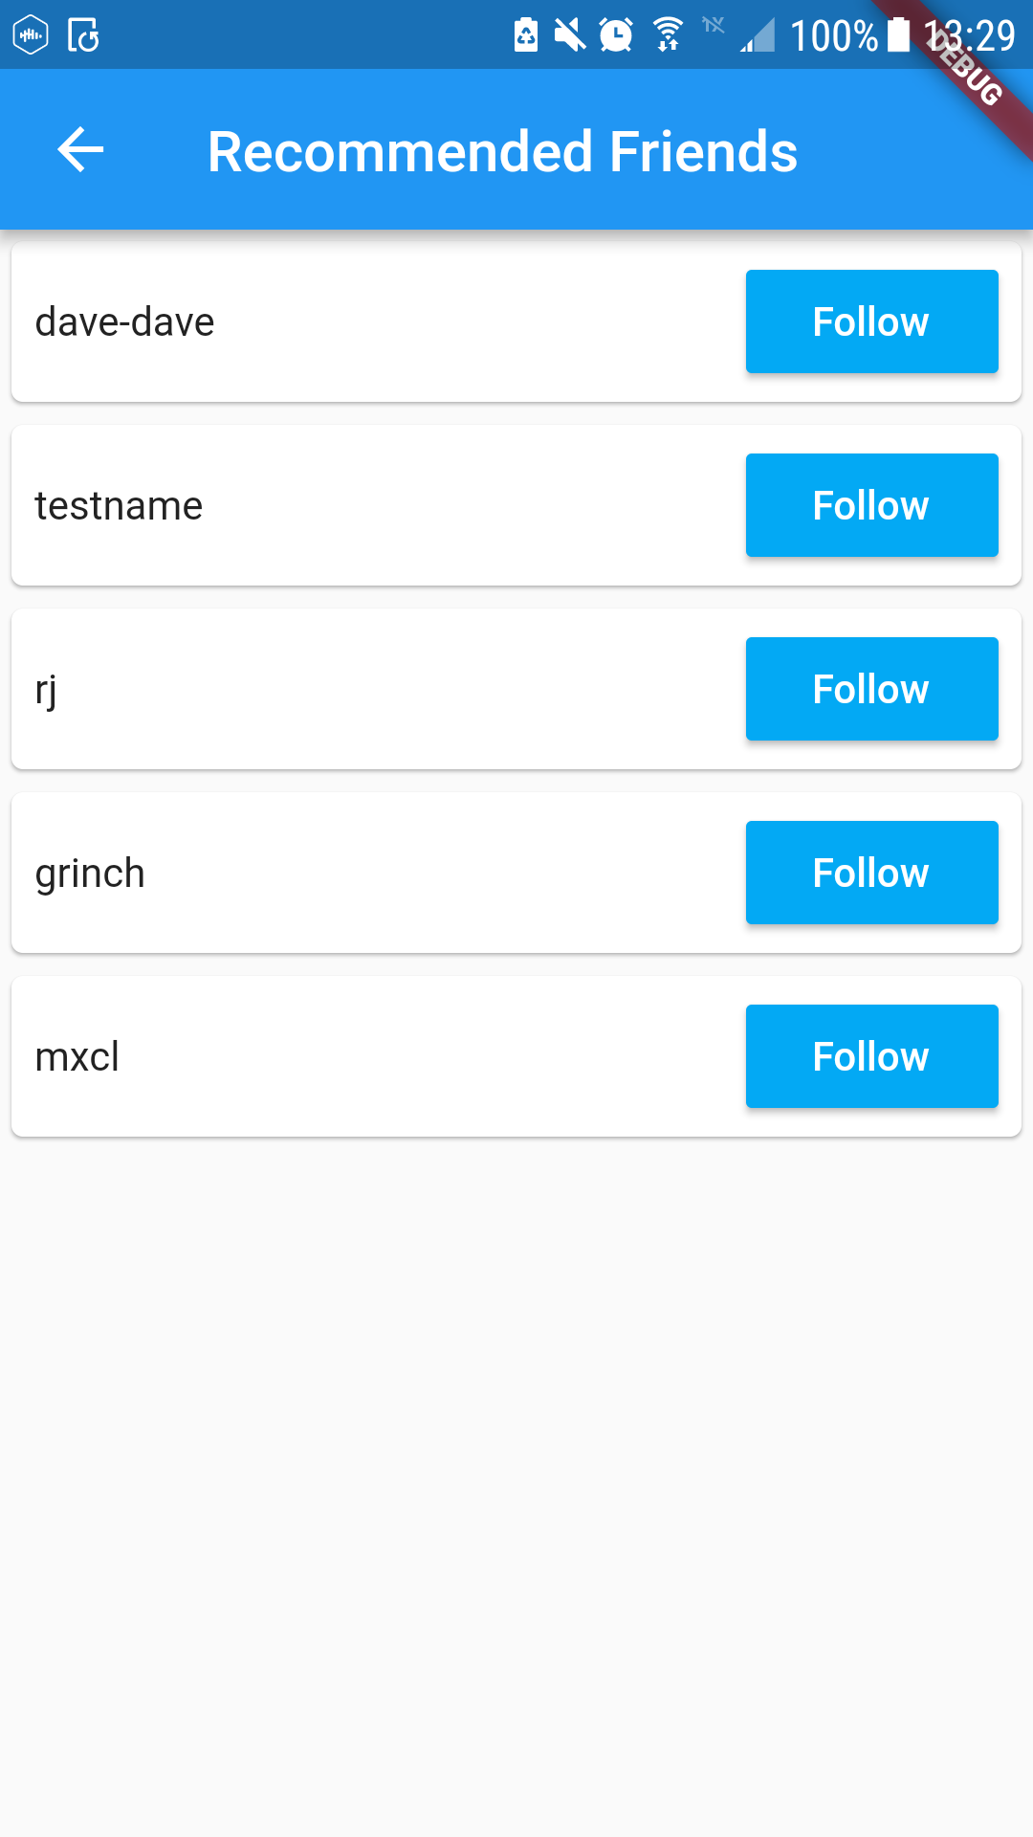

Figure 7. Recommended Friends

**4.6 Rated Songs**

When a user loads the *Rated Songs* page, the user sees two tabs towards the top of the screen: Liked Songs and Disliked Songs. When Rated Songs is loaded, it automatically goes to the Liked Songs tab.

**4.6.1 Likes**

*Liked Songs* displays all the songs that the user logged in has liked. You see the

song title along with the like and dislike buttons. In Liked Songs, the like button

will be blue, meaning the song is already liked. The user can press the like button

again, which takes away a rating for that song, so when the user refreshes the

Rated Songs page that song will not be listed under Liked Songs. The user can

also press the dislike button, which changes the rating of that song to be disliked.

When the user refreshes the Rated Songs page that song will not be listed under

Liked Songs, but will be listed under Disliked Songs.

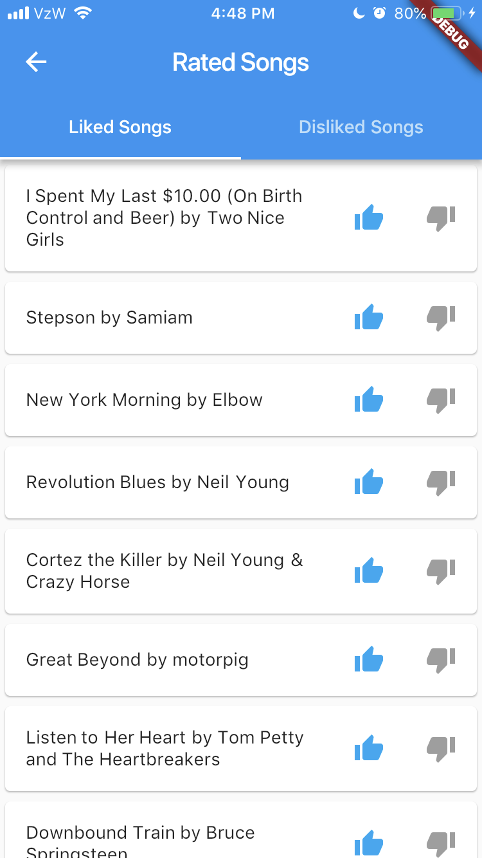

Figure 8. Rated Songs: Likes

**4.6.2 Dislikes**

*Disliked Songs* displays all the songs that the user logged in has disliked. You see the song title along with the like and dislike buttons. In Disliked Songs, the dislike button will be blue, meaning the song is already disliked. The user can press the dislike button again, which takes away a rating for that song, so when the user refreshes the Rated Songs page that song will not be listed under Disliked Songs. The user can also press the like button, which changes the rating of that song to be liked. When the user refreshes the Rated Songs page that song will not be listed under Disliked Songs, but will be listed under Liked Songs.

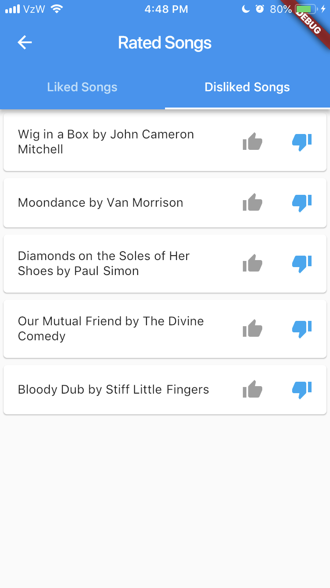

Figure 9. Rated Songs: Dislikes

**4.7 History**

*Listening History* displays all the songs the user logged in has listened to along with the rating for each song. The user has the option to change the rating for all the songs listed.

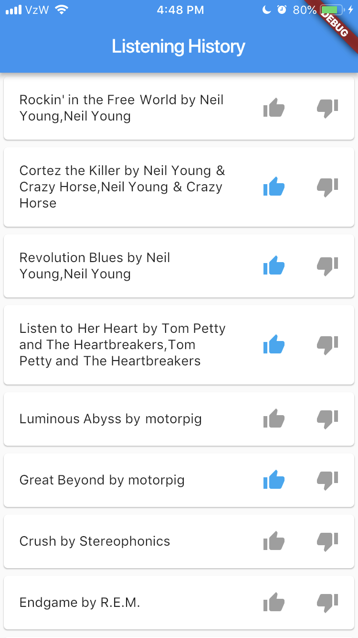

Figure 10. History

**4.8 Friends**

When a user loads the *Friends* page, the user sees two tabs towards the top of the screen: Users You Follow and Users Who Follow You. When the Friends page is loaded, it automatically goes to the Users You Follow tab.

**4.8.1 Users You Follow**

In the Users You Follow tab there is a list of users outputted that the user logged

in currently follows. For each username there is a button where you see

“Unfollow”, meaning you are currently following that user. If you click the Unfollow

button you unfollow that user. Then when you refresh the page that user will not

appear in the list of users that you follow. If you click on a username, a screen

will pop up with that users profile.

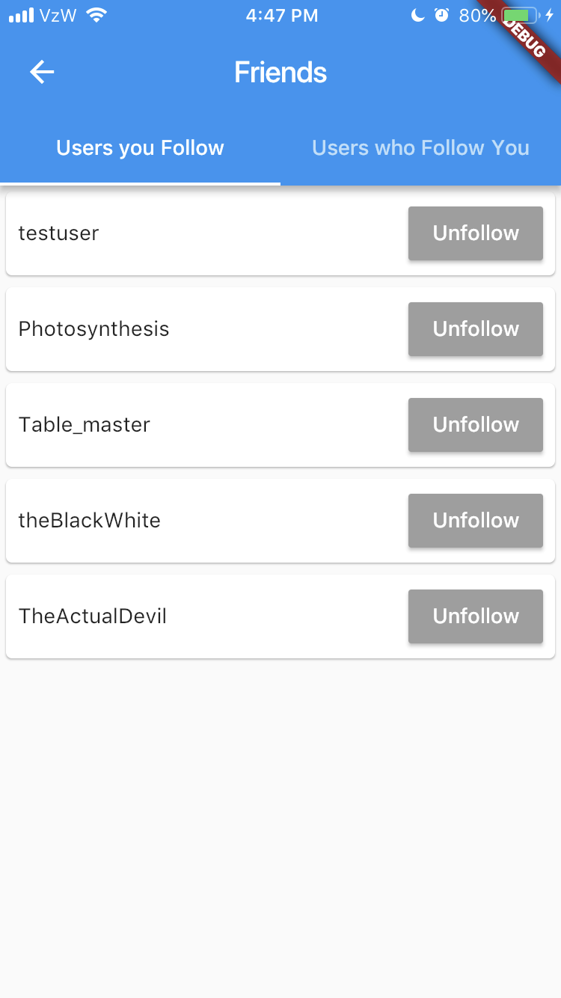

Figure 11. Friends Page: Users You Follow

**4.8.2 Users Who Follow You**

In the Users Who Follow You tab there is a list of users outputted that follow the

user logged in. For each username there is a button where you see “Follow” or

“Unfollow” (depending if you are following them back). If you click the Follow

button, you follow that user. If you click the Unfollow button you unfollow that user. Then when you refresh the page the status of whether you follow/unfollow that user will be updated. If you click on a username, a screen will pop up with that users profile.

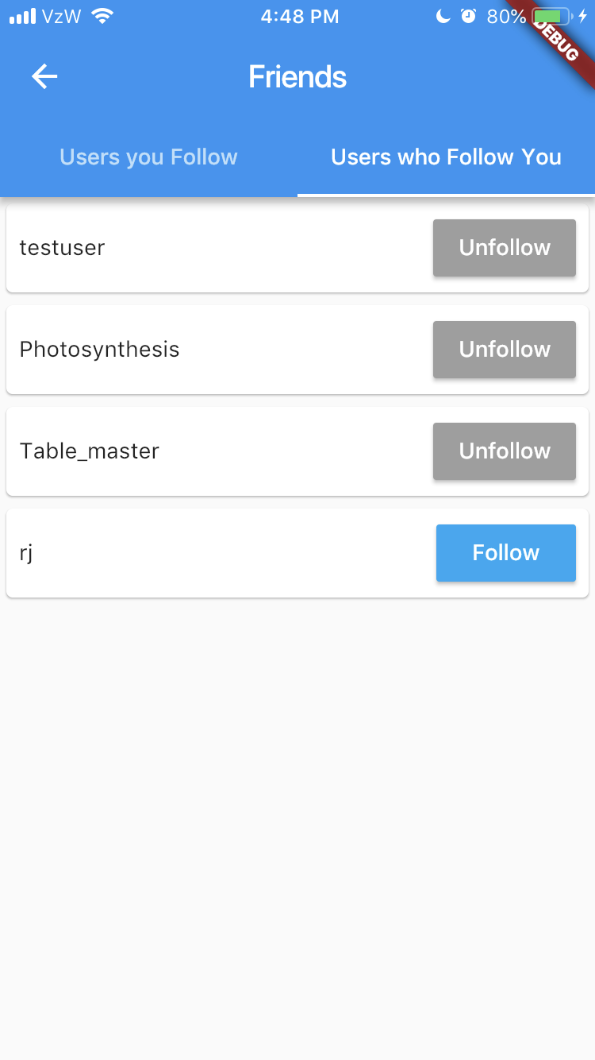

Figure 12. Friends Page: Users Who Follow You

**5.0 REPORTING ISSUES**

**5.0 REPORTING ISSUES**

This application is in its first development phase. Any issues a user encounters can be reported to this email: computerscience@rowan.edu